EMPLOYEE RAISE ISSUE – RECORD PRODUCER & SERVICE PORTAL INTEGRATION
PHASE 5: Creating a New Service Portal

1. Introduction
This phase creates a dedicated Service Portal where employees can access the Raise Employee Issue Record Producer through a clean self-service interface.

2. Objective
To configure the dedicated portal and the Employee Center portal page.

3. Service Portal Configuration
1. Navigate to Service Portal → Service Portal Configuration.
2. Open Service Portals.
3. Click New.
4. Enter the portal configuration values.
5. Save the portal.
Property | Configured Value
Title | Requesting Portal
URL suffix | employee_request
Homepage | ec_standard_home
KB home page | esc_knowledge_home
Login page | login
Logo | Upload required image
Main menu | Employee Center Menu
404 Page | 404
Theme | Employee Center Coral Theme
[ SCREENSHOT PLACEHOLDER ]
Service Portal configuration form
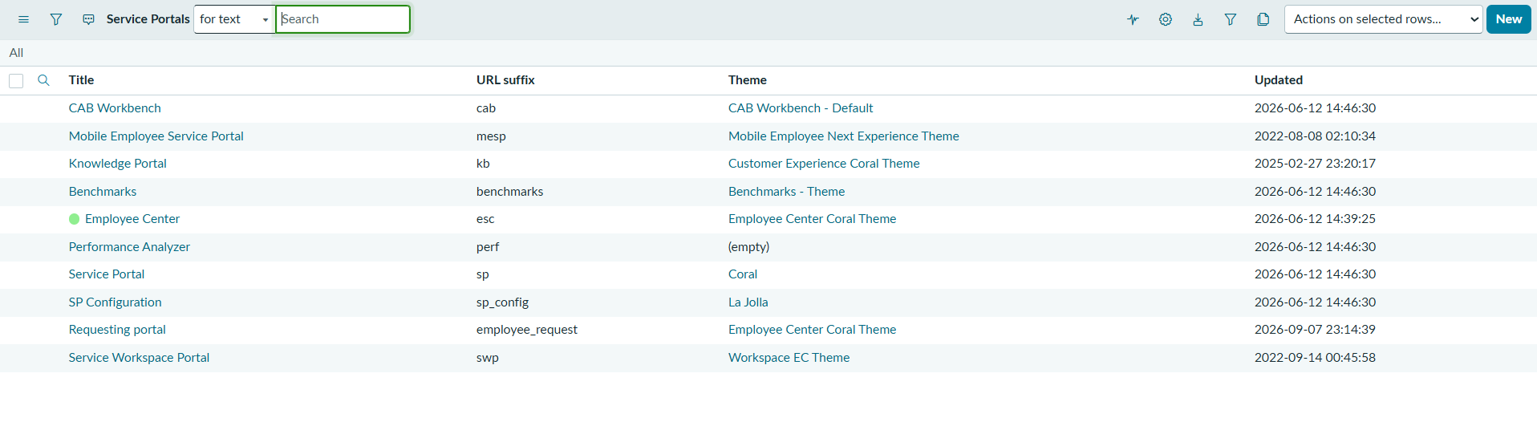
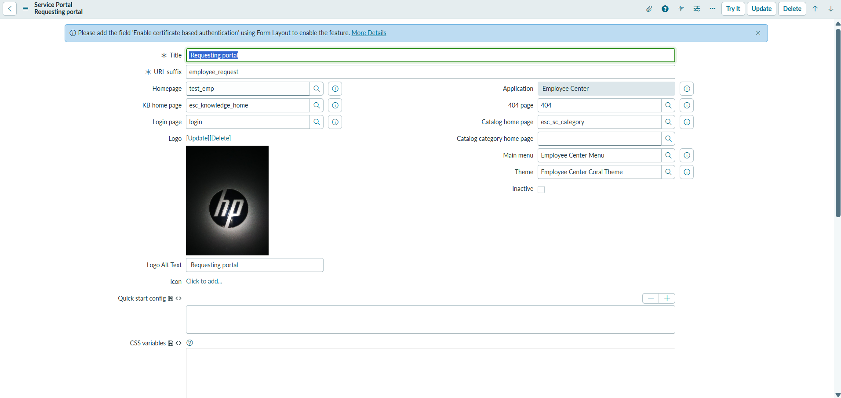

4. Creating the Employee Center Portal Page
1. Navigate to All → Service Portal.
2. Select Pages.
3. Click New.
4. Set Title to Employee Center Portal Page.
5. Set ID to employee_center_portal_page.
6. Save the page.
Employee Center Portal Page configuration
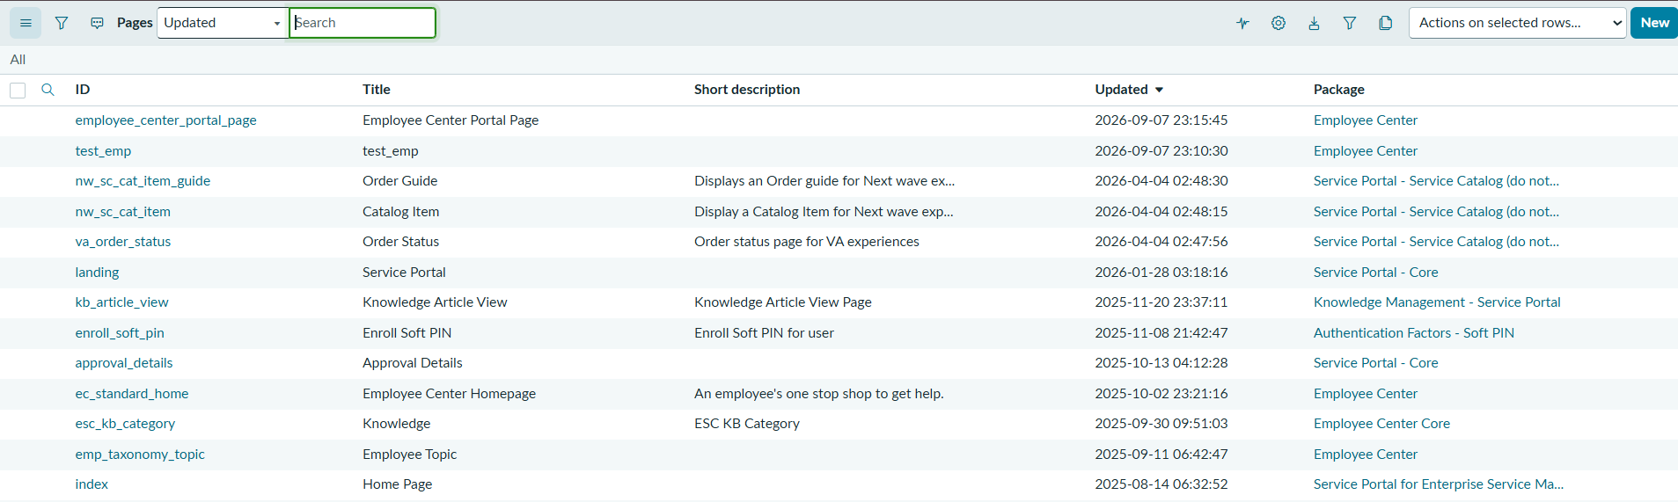

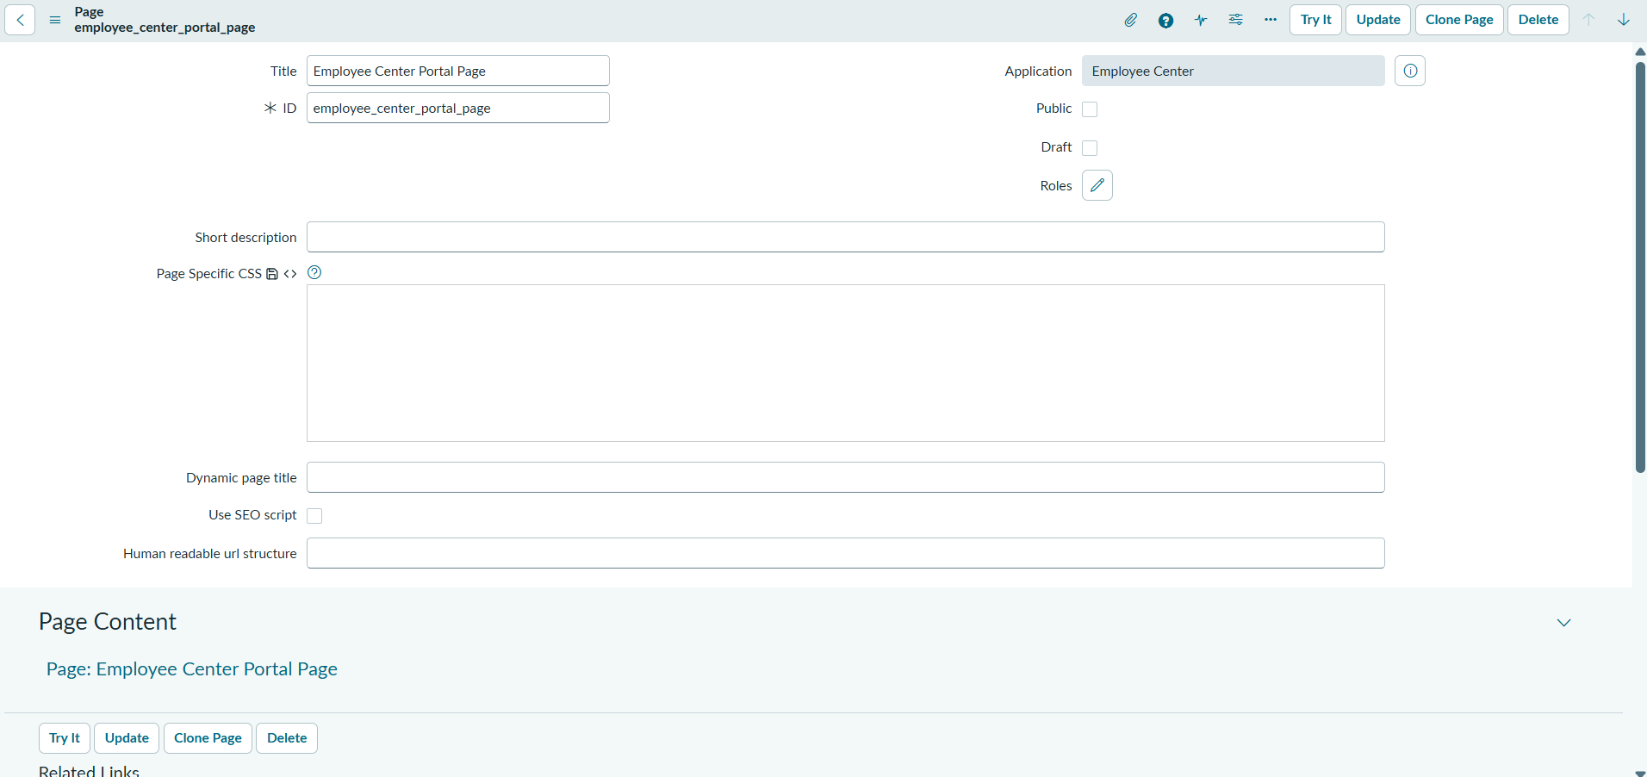

5. Result
The employee_request Service Portal and Employee Center Portal Page were configured successfully and are ready to host the Record Producer and custom widgets.

